**6. Results and Discussion**

Python has emerged as one of the most simple and efficient languages for implementing deep learning algorithms. It is used in various image classification and segmentation tasks.The code for the present work was written in Python. The following important libraries of Python were utilized for developing the proposed model: Keras, Tensorflow,and h5py

#### **6.1. Results for Segmentation of Pneumothorax**

The proposed LENET model identify the images and found the pneumothorax disease. Further, it assigns class labels for each detected region with a prediction confidence score.The image shown in **Fig:** depicts the generated on a sample taken from the validation dataset. The proposed model predicted the confidence score for each image efficiently.

#### **Analysis Based on Loss Scores**

The loss score of a neural network represents the prediction error of the model. A curve can be plotted to represent the loss generated by the predictions of a model. The model is designed to minimize the loss function.

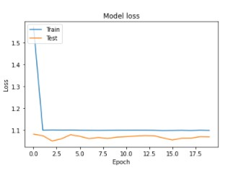

**Fig: 4.4** CNN model trained dataset loss values

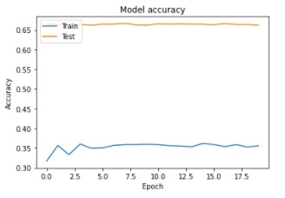

**Fig: 4.3** CNN model trained dataset accuracy

**5.8 Evaluation metrics**

The evaluation of the classification considered four metrics: Specificity (Sp), Sensitivity (Se), Accuracy (Acc), and AUC. The AUC is an area under the Receiver Operating Characteristics (ROC) curve. The AUC is calculated by Riemann sum with a set of thresholds to compute pairs of True Positive Rate (TPR) and False Positive Rate (FPR). Hosmer and Lemeshow provided the guidelines for rating the AUC values (Hosmer, Lemeshow, and Sturdivant 2013). **Table 4** describes the brief guideline rules of the AUC interpretation. Specificity is the fraction of negative test results that are correctly identified as normal. Sensitivity is the probability of positive test results that are correctly identified as pneumothorax. Accuracy is the average of specificity and sensitivity. Specificity and sensitivity are defined with four measurements in following: • True Positive (TP): Correctly detected as pneumothorax • True Negative (TN): Correctly detected as normal • False Positive (FP): Incorrectly detected as pneumothorax • False Negative (FN): Incorrectly detected as normal Using the above measurement, specificity (Sp) and sensitivity (Se) are defined in following:

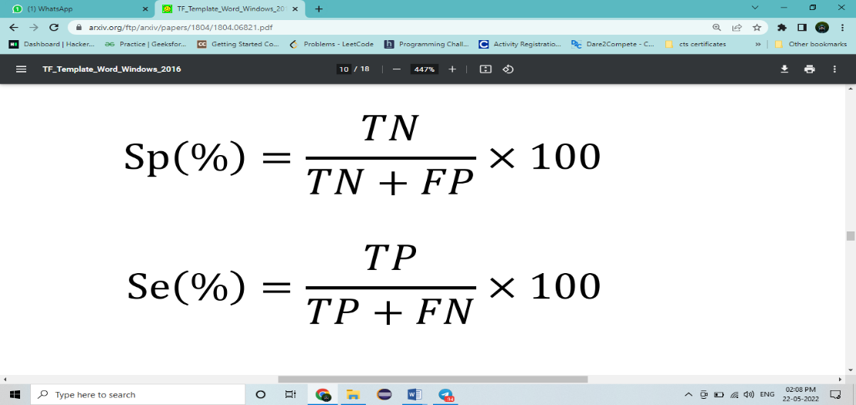

There is a trade-off between specificity and sensitivity. When the softmax layer is used as the final prediction layer, it classifies the input as the class with the highest probability. The problem is that medical data generally consists of multiple normal and few abnormal (disease) data. In this case, training is processed in the direction of reducing the loss of normal which occupies the majority in the mini-batch. Therefore, when the probability of softmax is directly used for class determination, extremely high specificity and low sensitivity are obtained. To avoid this problem, we chose the cut-off value as the point where the sum of specificity and sensitivity in the ROC curve is the maximum.

**TABLE 4**

**TABLE 4 AUC interpretation & guidelines**

|  |  |
| --- | --- |
| AUC interpretation guidelines | AUC Guidelines |
| 0.5 – 0.6 | No discrimination |
| 0.6 – 0.7 | Poor discrimination |
| 0.7 – 0.8 | Acceptable discrimination |
| 0.8 – 0.9 | Good discrimination |
| 0.9 – 1.0 | Excellent discrimination |

s